AI-EXHIBITS · EXHIBIT DOCUMENTATION
Sliding Puzzle
Train your own AI — reinforcement learning on sliding puzzles of growing size
Live exhibit: https://erikaroldanroa.github.io/ai-exhibits-rl-public/ · EN · FR · DE · IT · in situ and pop-up exhibit
Source code: github.com/ErikaRoldanRoa/ai-exhibits-rl-public
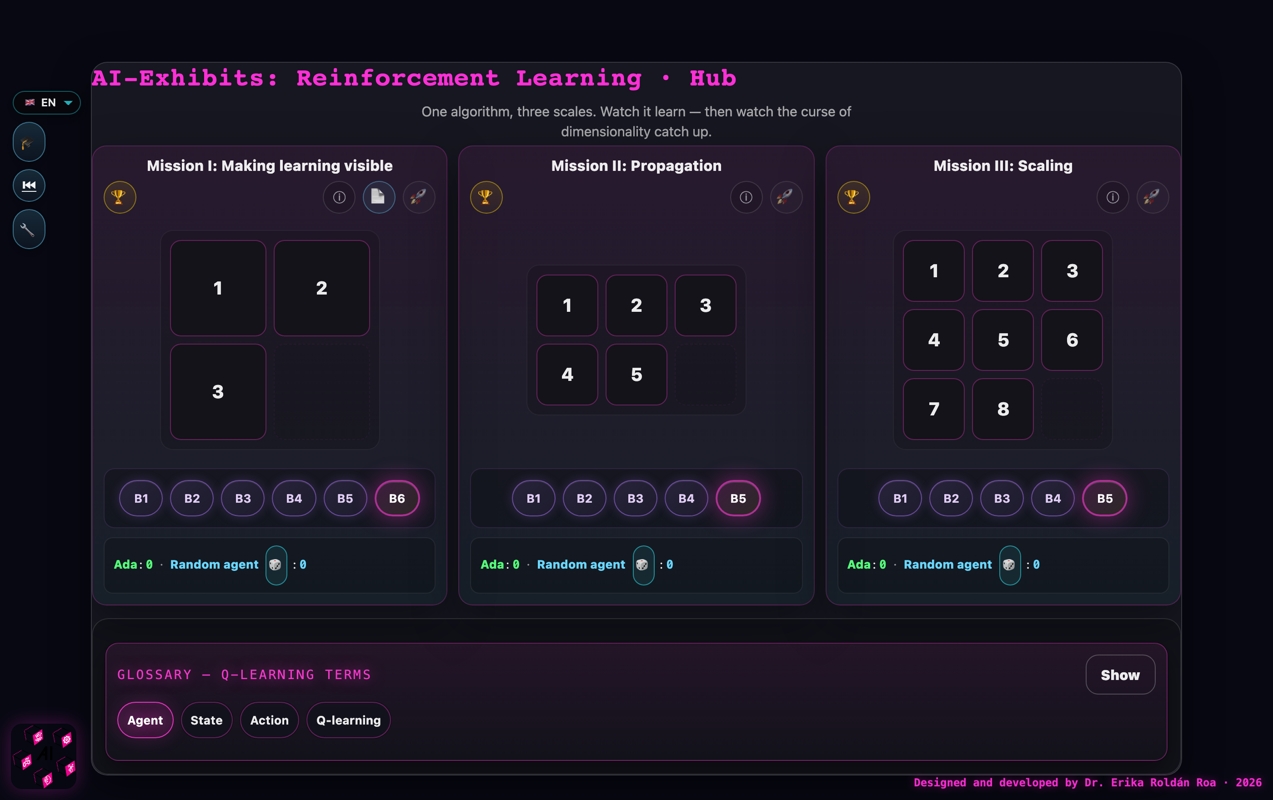
The hub: three missions, one Q-learning algorithm — the scale escalates from 12 to 181 440 states.

Description
The exhibit “Sliding Puzzle” lets visitors train their own reinforcement-learning agent on three sliding puzzles of growing size: 2×2, 2×3, and 3×3. It runs in any browser in four languages, needs no installation or account, and works offline after the first visit, so it can be used both as an unattended exhibition station and as a classroom pop-up exhibit.
Each mission shows the puzzle next to a live visualization of its state space — every arrangement of the tiles is a state, every legal move an edge. Visitors first solve the puzzle by hand, then press “Train” and watch a Q-learning agent learn it: Q-values cascade backward from the goal through the graph, episode by episode, while a progress bar shows the share of states explored. Three sliders expose the mathematics of the algorithm — the learning rate α, the discount factor γ, and the exploration rate ε — and benchmark buttons let visitors race the trained agent against scrambled configurations. Printable A4 kits (facilitator runbook, student worksheet with the 12-state orbit and the 24-row Q-table, team scoresheet) accompany the exhibit for workshop use.
 | Mission I | Mission II | Mission III
Puzzle | 2 × 2 | 2 × 3 | 3 × 3
Reachable states | 12 | 360 | 181 440
God’s Number | 6 | 21 | 31
Default training | ~5 s | ~1 min | 10+ min, incomplete

Activity
Each mission follows the same arc: read the world → play by hand → train the agent → debrief.
Mission I (2×2). Participants solve the puzzle by hand on the screen, then train the agent for 300 episodes and watch the Q-values propagate backward through the 12-state graph until the whole table converges in seconds. Working with the printed worksheet, they can fill in the 24-row Q-table themselves and verify that optimal play never needs more than 6 moves.
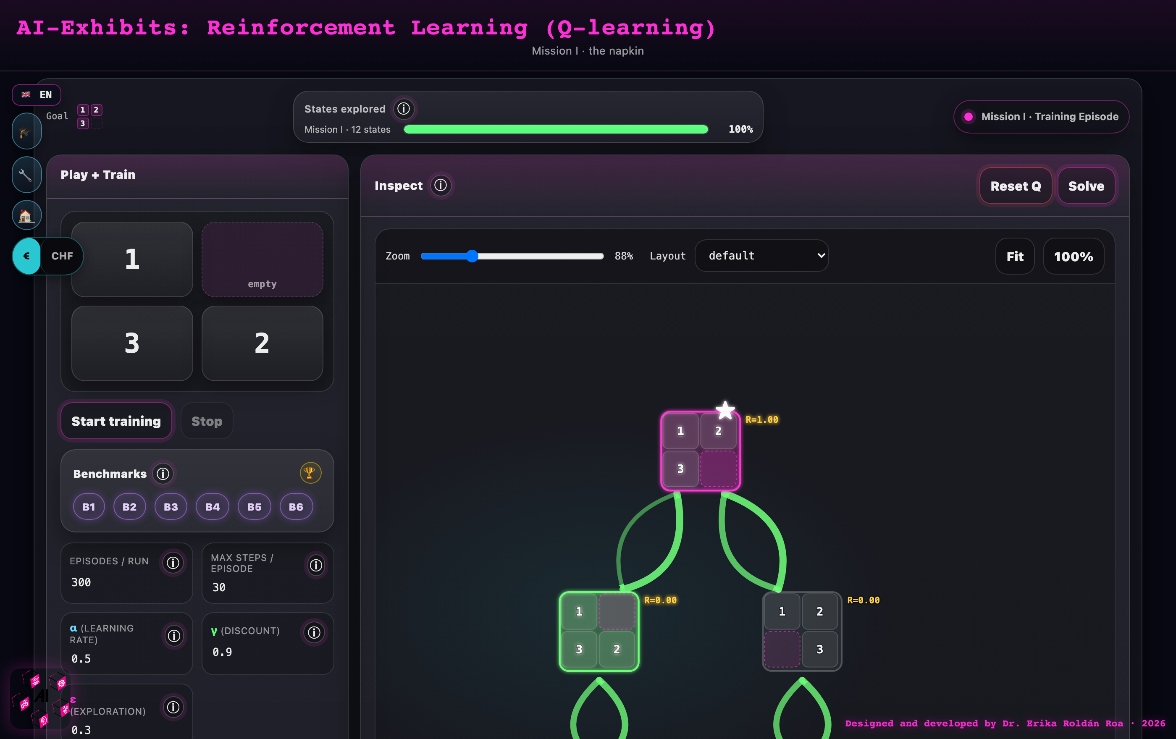
Mission I after training: the full 12-state graph, Q-values converged — the whole universe of the puzzle on one screen.
Mission II (2×3). Participants re-train the agent under different hyperparameters: raising the discount factor γ from 0.5 to 0.99 shows reward reaching deeper into the state space; raising the exploration rate ε from 0 to 0.5 shows the explored-states bar filling at very different speeds.
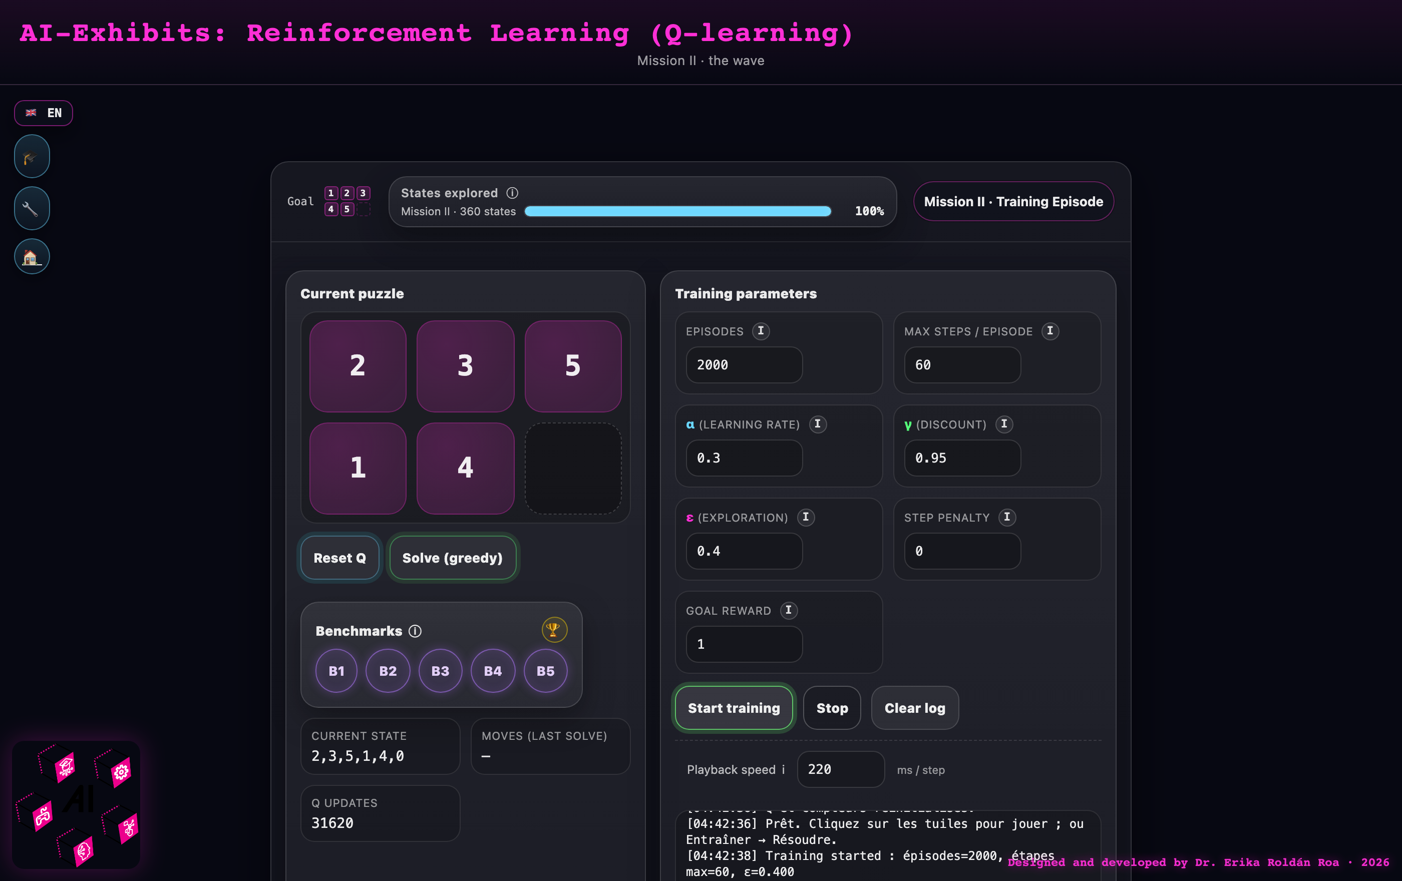
Mission II: the training parameters α, γ, ε in the visitor’s hands — 360 states, fully explored.
Mission III (3×3). The same algorithm meets 181 440 reachable states. Even after 10 000 episodes the explored-states bar plateaus far below 100% — the lookup table has hit its ceiling. An economy card translates the gap into money (a demo costs fractions of a cent; a guaranteed full table, hundreds of euros of compute), making the curse of dimensionality tangible.
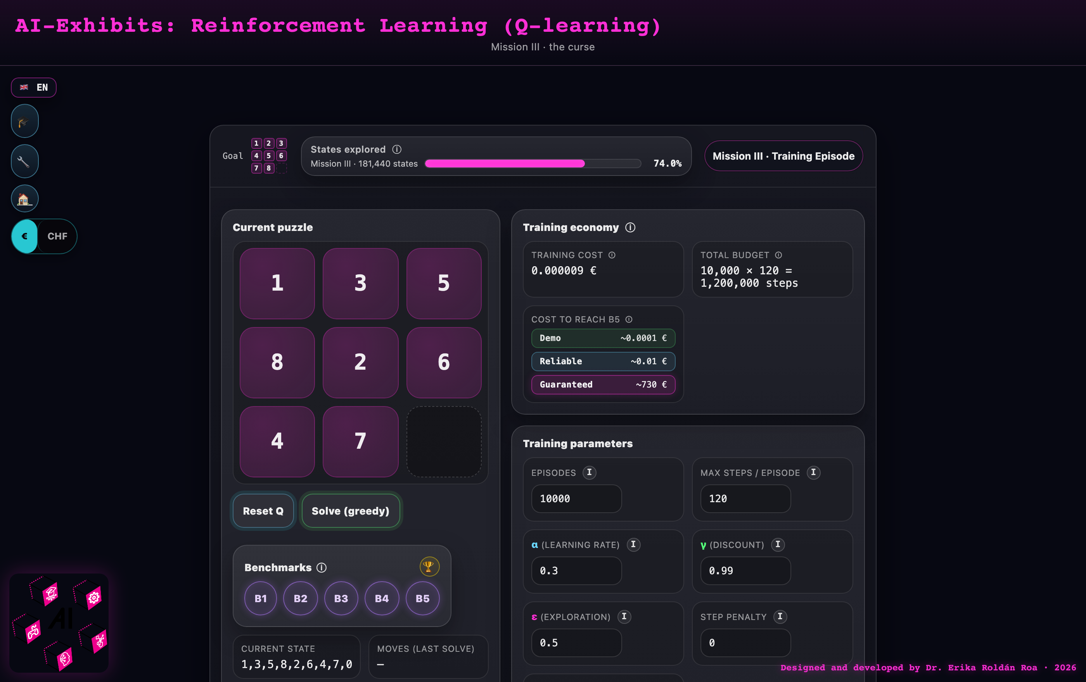
Mission III: after 10 000 episodes the bar plateaus — the curse of dimensionality, priced in euros.
The activity can end in different ways: the agent converges to an optimal policy (Missions I–II), the visitor stops training with a partially learned policy, or — the intended ending of Mission III — the group discusses why the table cannot be filled and what could fix it, which opens the door to neural networks (DQN, AlphaZero).

Further explorations
The exhibit extends naturally to sliding puzzles with other geometries and dimensions, based on the research papers behind it:
- Hands-on: solving 3D-printed hexagonal sliding puzzles that require different numbers of empty tiles to be solvable — a concrete encounter with parity classes as an invariant that blocks solutions [2].
- A video game for 3D and 4D cubical sliding puzzles, where the empty tile of the 2D puzzle becomes a free face and human intuition starts to struggle [3].
- Comparing how three algorithmic families solve the same puzzle — A* search (optimal but expensive), evolutionary algorithms (robust and scalable, no optimality guarantee), and reinforcement learning (improves from experience) — via videos showing moves and computation time [1].
A mediator needs the 3D-printed hexagonal puzzles, a screen for the video game and videos, and optionally the three research papers [1–3] displayed at the station.

Background information
Reinforcement learning is one of the main paradigms of machine learning: an agent learns from interaction rather than from labelled examples. Dropped into an environment, it acts, observes the resulting state, and receives a reward — here +1 on reaching the goal configuration and 0 otherwise. Q-learning stores, for every (state, action) pair, a number estimating the cumulative future reward; each move updates this Q-value using the reward received and the best Q-value available in the next state. The discount factor γ determines how far reward propagates backward from the goal; the exploration rate ε keeps the agent trying new moves instead of only exploiting what it already knows.
The puzzles themselves carry the mathematics. Only half of all n! tile permutations are reachable: a parity invariant splits the configuration space in two, and the goal lives in one half. God’s Number — the worst-case shortest solution — equals the diameter of the state graph: 6 for the 2×2, 21 for the 2×3, and 31 for the 3×3, each verified by breadth-first search. The factorial growth of the state space (12 → 360 → 181 440) is exactly why tabular Q-learning fails at scale and why modern RL replaces the lookup table with neural networks — the same principles (agent, reward, policy, value estimation) that drive game-playing agents, robotics, and recommendation systems.

Didactical information
Suitable from age 13; no prior knowledge of RL is needed — Mission I teaches everything from scratch. Recommended setup: one browser per pair or small group, plus the hub projected on a shared screen so the room watches the explored-states bar climb together. Mission I alone takes about 30 minutes; all three missions about 2 hours. Letting participants predict what a slider change will do before re-training (e.g. “what happens if ε = 0?”) reliably produces the most discussion. The printed kits let participants compute Q-values by hand before the machine does — keeping the tool from being smarter than the student. The exhibit was piloted in school workshops at Maison Poincaré, Paris (January 2026, two Seconde classes) and at a mathematics camp at the University of Geneva (April 2026).
Printable materials (A4 — open in the browser and print; each link opens directly in English):
- Mission I kit · facilitator runbook
- Mission II kit · facilitator runbook
- Mission III kit · facilitator runbook
- Mission I student worksheet (12-state orbit, 24-row Q-table)
- Team scoresheet — all three missions on one page

References
[1] Nono SC Merleau, Miguel O’Malley, Érika Roldán, and Sayan Mukherjee. Approximately Optimal Search on a Higher-dimensional Sliding Puzzle. arXiv:2412.01937, 2024. https://arxiv.org/abs/2412.01937
[2] Ray Karpman and Érika Roldán. Parity Property of Hexagonal Sliding Puzzles. arXiv:2201.00919, 2022. https://arxiv.org/abs/2201.00919
[3] Moritz Beyer, Stefano Mereta, Érika Roldán, and Peter Voran. Higher-dimensional Cubical Sliding Puzzles. arXiv:2307.14143, 2023. https://arxiv.org/abs/2307.14143
 Co-funded by the European Union
Exhibit created by Dr. Erika Roldán Roa (Max Planck Institute for Mathematics in the Sciences, Leipzig) within the AI-Exhibits Erasmus+ partnership: MPI MiS · IMAGINARY · Institut Henri Poincaré · Citizens in Power · ITT Giordani Striano. License CC BY-NC-ND 4.0.

